

**Batch: B-1 Roll No.: 16010422234 Name: Chandana Ramesh Galgali**

**Experiment No.: 5**

**Aim:** Write a program for following operations on Binary Search Tree using Doubly Linked List (DLL).

1. Create empty BST,
2. Insert a new element on the BST
3. Search for an element on the BST
4. Delete an element from the BST
5. Display all elements of the BST

___________________________________________________________________________

**Resources needed:** C/C++/JAVAeditor and compiler

**___________________________________________________________________________**

**Theory**

**Binary Tree :-**

A binary tree is made of nodes, where each node contains a "left" reference, a "right" reference, and a data element. The topmost node in the tree is called the root.

Every node (excluding a root) in a tree is connected by a directed edge from exactly one other node. This node is called a parent. On the other hand, each node can be connected to an arbitrary number of nodes, called children. Nodes with no children are called leaves, or external nodes. Nodes which are not leaves are called internal nodes. Nodes with the same parent are called siblings.

**Example**

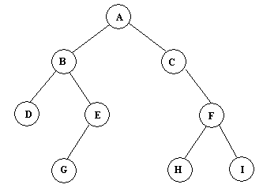

Figure(a): Binary Tree Example

**Traversals :**

A traversal is a process that visits all the nodes in the tree. Since a tree is a nonlinear data structure, there is no unique traversal. We will consider several traversal algorithms with the following two kinds.

1. depth-first traversal
2. breadth-first traversal

There are three different types of depth-first traversals, :

* PreOrder traversal - visit the parent first and then left and right children;
* InOrder traversal - visit the left child, then the parent and the right child;
* PostOrder traversal - visit the left child, then the right child and then the parent.

There is only one kind of breadth-first traversal--the level order traversal. This traversal visits nodes by levels from top to bottom and from left to right.

Consider an example the following tree and its four traversals:

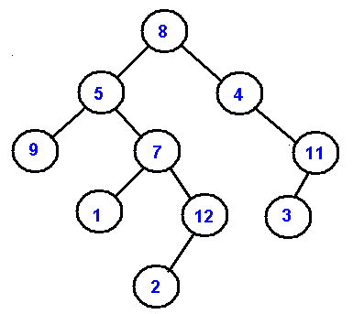

**Binary Search Tree(BST):** It is a binary tree where elements are stored in a particular order such that the left child is less than the parent and parent is less than the right child. This small modification makes BST efficient for searching. It is also called the BST property.

**Example of BST** following fig is the example BST whose root is 15 and follows the BST property.

## http://staff.ustc.edu.cn/%7Ecsli/graduate/algorithms/book6/247_a.gif

## Methods for storing binary trees

Binary trees can be constructed from programming language primitives in several ways.

### Nodes and references

In a language with records and [references](https://en.wikipedia.org/wiki/Reference_%28computer_science%29), binary trees are typically constructed by having a tree node structure which contains some data and references to its left child and its right child. Sometimes it also contains a reference to its unique parent. If a node has fewer than two children, some of the child pointers may be set to a special null value, or to a special [sentinel node](https://en.wikipedia.org/wiki/Sentinel_node).

Binary Search Tree can be implemented as a linked data structure in which each node is an object with two pointer fields. The two pointer fields *left and right* point to the nodes corresponding to the left child and the right child NULL in any pointer field signifies that there exists no corresponding child.

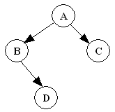 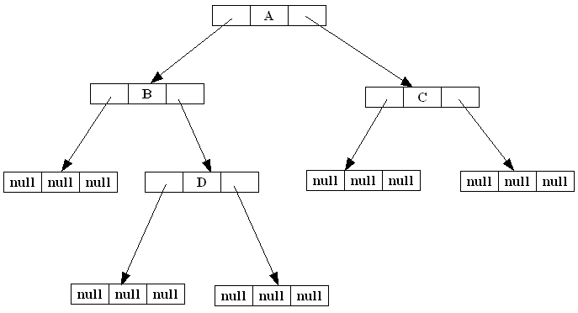

Figure : Binary Search Trees example

**___________________________________________________________________________**

**Algorithm:**

**1. createBST()** – This function should create a ROOT pointer with NULL value as empty BST.

**2. insert( typedef newelement )** – This void function should take a newelement as an argument to be inserted on an existing BST following the BST property.

**3. typedef search(typedef element )** – This function should search for a specified element on the non-empty BST and return a pointer to it.

**4**. **typedef delete(typedef element)** – This function searches for an element and if found deletes it from the BST and returns the same.

**5**. **typedef getParent(typedef element)** - This function searches for an element and if found, returns its parent element.

**6. DisplayInorder( )** – This is a void function which should go through non- empty BST, traverse it in inorder fashion and print the elements on the way.

**NOTE : All functions should be able to handle boundary(exceptional) conditions.**

**Activity:** Write pseudocode for each method and implement the same.

**Results:** A program depicting the correct behavior of BST and capable of handling all possible exceptional conditions and the same is reflected clearly in the output.

**____________________________________________________________________________**

**Program with output:**

#include <stdio.h>

#include <stdlib.h>

#include <malloc.h>

struct Node

{

int data;

struct Node* left;

struct Node* right;

};

struct Node* createNode(int data)

{

struct Node* newNode = (struct Node*)malloc(sizeof(struct Node));

newNode->data = data;

newNode->left = NULL;

newNode->right = NULL;

return newNode;

}

struct Node* insert(struct Node* root, int newElement)

{

if(root == NULL)

{

return createNode(newElement);

}

else if(newElement < root->data)

{

root->left = insert(root->left, newElement);

}

else if (newElement > root->data)

{

root->right = insert(root->right, newElement);

}

return root;

}

struct Node* search(struct Node* root, int element)

{

if (root == NULL || root->data == element)

{

return root;

}

else if (element < root->data)

{

return search(root->left, element);

}

else if (element > root->data)

{

return search(root->right, element);

}

}

struct Node* delete(struct Node* root, int element)

{

if (root == NULL)

{

return root;

}

else if (element < root->data)

{

root->left = delete(root->left, element);

}

else if (element > root->data)

{

root->right = delete(root->right, element);

}

else

{

if (root->left == NULL)

{

struct Node* temp = root->right;

free(root);

return temp;

}

else if (root->right == NULL)

{

struct Node* temp = root->left;

free(root);

return temp;

}

struct Node* minRight = root->right;

while (minRight->left != NULL)

{

minRight = minRight->left;

}

root->data = minRight->data;

root->right = delete(root->right, minRight->data);

}

return root;

}

void displayinorder(struct Node* root)

{

if (root != NULL)

{

displayinorder(root->left);

printf("%d ", root->data);

displayinorder(root->right);

}

}

int main()

{

struct Node* root = NULL;

int choice, element;

do

{

printf("\n1.Insert\n2.Search\n3.Delete\n4.Display\n5.Exit");

printf("\nEnter your choice: ");

scanf("%d", &choice);

switch(choice)

{

case 1:

printf("\nEnter the element to insert: ");

scanf("%d", &element);

root = insert(root, element);

break;

case 2:

printf("\nEnter the element to search: ");

scanf("%d", &element);

if (search(root, element) != NULL)

{

printf("\nElement found in the BST.");

}

else

{

printf("\nElement not found in the BST.");

}

break;

case 3:

printf("\nEnter the element to delete: ");

scanf("%d", &element);

root = delete(root, element);

break;

case 4:

printf("\nElements of the BST: ");

displayinorder(root);

printf("\n");

break;

case 5:

break;

default:

printf("\nInvalid choice! Please try again.");

}

}

while (choice != 5);

return 0;

}

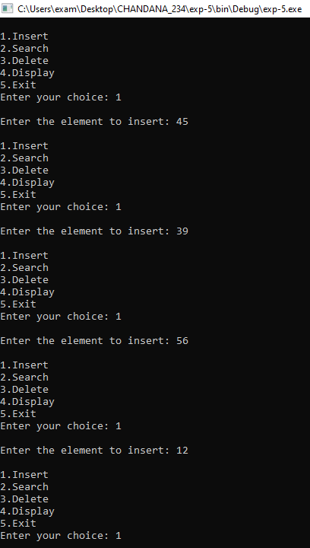

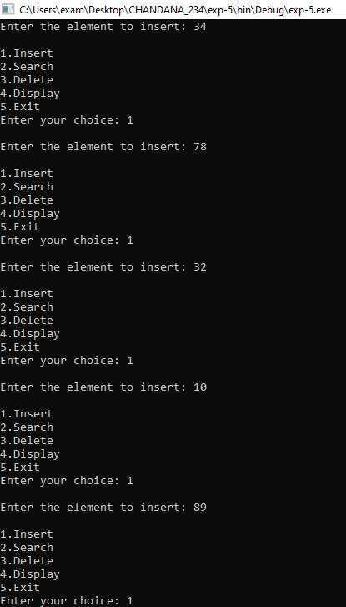

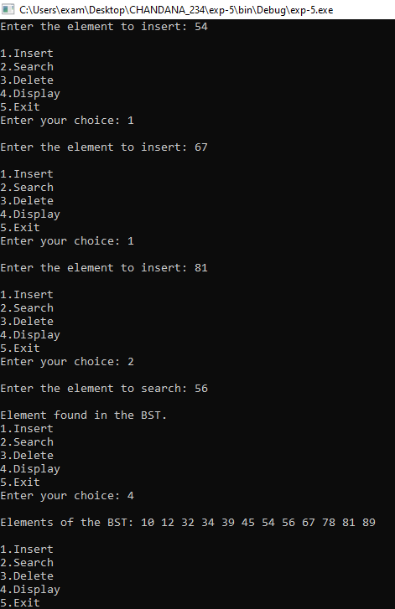

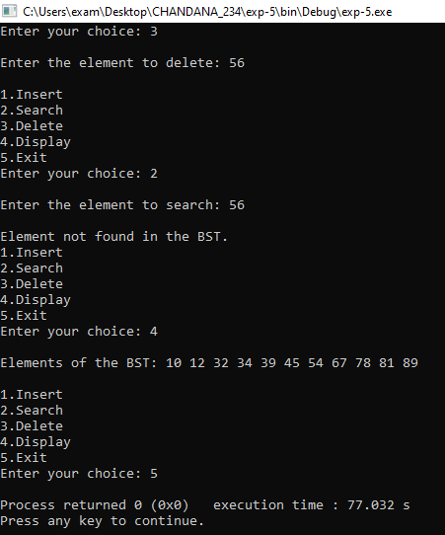

**Outcomes:** Apply linear and non-linear data structure in application development.

**Conclusion:** The experiment was successful in implementing a program for performing operations on a BST using a DLL, and the program exhibited the desired behavior and functionality.

**Grade: AA / AB / BB / BC / CC / CD /DD**

**Signature of faculty in-charge with date _____________________________________________________________________________**

**References:**

**Books/ Journals/ Websites:**

* Y. Langsam, M. Augenstin and A. Tannenbaum, “Data Structures using C”, Pearson Education Asia, 1st Edition, 2002.
* https://ds1-iiith.vlabs.ac.in/exp/binary-search-trees/index.html